## PREDICT TINDER MATCHES USING ML



***A Project Report submitted in partial fulfilment of the requirements***

***for the award of the degree of***

**Bachelor of Technology**

in

## Computer Science and Engineering Specialization in

**Artificial Intelligence and Machine Learning**

#### by

**Himanshu Sharma Trapti Goyal Akshat Saxena Preeti Yadav 201550062 201550140 201550016 201550105**

Group No. 20

Under the Guidance of Mr. Aditya Upadhyay

Department of Computer Engineering & Applications

## Institute of Engineering & Technology

### GLA University Mathura- 281406, INDIA

**April, 2024**

##### Department of Computer Engineering and Applications GLA University, 17 km Stone, NH#2, Mathura-Delhi Road,

**P.O. Chaumuhan, Mathura-281406 (U.P.)**

**Declaration**

I hereby declare that the work which is being presented in the B.Tech. Project **“Predict Tinder Matches using ML”**, in partial fulfillment of the requirements for the award of the ***Bachelor of Technology*** in Computer Science and Engineering Specialization in Artificial Intelligence and Machine Learning and submitted to the Department of Computer Engineering and Applications of GLA University, Mathura, is an authentic record of my own work carried under the supervision **Mr. Aditya Upadhyay (Assistant Professor).**

The contents of this project report, in full or in parts, have not been submitted to any other Institute or University for the award of any degree.

Sign Sign

Name of Student: Himanshu Sharma Name of Student: Trapti Goyal University Roll No.: 201550062 University Roll No.: 201550140

Sign Sign

Name of Student: Akshat Saxena Name of Student: Preeti Yadav University Roll No.: 201550016 University Roll No.: 201550105

**Certificate**

This is to certify that the above statements made by the candidate are correct to the best of my/our knowledge and belief.

**Supervisor**

(**Mr. Aditya Upadhyay**) Assistant Professor

Dept. of Computer Engg, & App.

**Project Co-ordinator Program Co-ordinator**

##### (Dr. Mayank Srivastava) (Mr. Jitesh Kumar Bhatia)

Associate Professor Assistant Professor

Dept. of Computer Engg, & App. Dept. of Computer Engg, & App.

Date:

### ACKNOWLEDGEMENT

It gives us a great sense of pleasure to present the Project report undertaken during

B. Tech. This project is an acknowledgment of the inspiration, drive and technical assistance contributed to it by many individuals. This project would never have seen the light of the day without the help and guidance that we have received.

Our heartiest thanks to Dr. Rohit Agrawal, Head of Dept., Department of CEA for providing us with an encouraging platform to develop this project, which thus helped usin shaping our abilities towards a constructive goal.

We owe a special debt of gratitude to Mr. Aditya Upadhyay, Assistant Professor, Institute of Engineering & Technology, for her constant support and guidance throughout the course of our work. Her sincerity, thoroughness, and perseverance have been a constant source of inspiration for us. She has showered us with all his extensively experienced ideas and insightful comments at virtually all stages of the project & has also taught us about the latest industry-oriented technologies.

We also would not like to miss the opportunity to acknowledge the contribution of all faculty members of the department for their kind guidance and cooperation during the development of our project. Last but not the least, we acknowledge our friends for their contribution to the completion of the project.

Sign Sign

Name of Candidate: Himanshu Sharma Name of Candidate: Trapti Goyal University Roll No.: 201550062 University Roll No.: 201550140

Sign Sign

Name of Candidate: Akshat Saxena Name of Candidate: Preeti Yadav University Roll No.: 201550016 University Roll No.: 201550105

### ABSTRACT

*In the realm of modern dating applications, Tinder has been a pioneering force, reshaping the landscape of online romance since its inception in 2012. This project, titled "Predicting Tinder Matches with Machine Learning," seeks to amplify and optimize the online dating experience by harnessing the capabilities of machine learning. Its primary objective is to develop an intelligent matchmaking system that enhances user interactions on Tinder-like platforms. This project unfolds through meticulous phases: data acquisition, preprocessing, feature engineering, algorithm selection, model training, evaluation, and recommendation generation. Leveraging machine learning algorithms, including cosine similarity and others, we aim to predict potential matches by meticulously analyzing user profiles, preferences, and activity metrics. Crucially, we uphold strict privacy standards and ethical considerations, ensuring user consent and safeguarding sensitive data. Our project's impact extends beyond algorithmic precision; it strives to elevate user satisfaction and create more meaningful connections in the dynamic digital dating sphere.*

*As we embark on this transformative journey, we remain dedicated to augmenting and redefining the online dating experience, recognizing the immense and transformative potential of technology in the realm of modern relationships.*

|  |  |  |
| --- | --- | --- |
|  | **CONTENTS** |  |
| Declaration Certificate Acknowledge Abstract Contents  List of figures |  | ii ii iii iv v vii |
| **CHAPTER 1** | **Introduction** | **1** |
| 1.1 | Overview and Motivation | 1 |
| 1.2 | Objective | 3 |
| 1.3 | Key Challenges and Potential Solutions | 5 |
| 1.4 | Contribution | 6 |
| 1.5 | Scope Definition | 7 |
| 1.6 | Summary of Similar Application | 8 |
| 1.7 | Organization of the Project | 9 |
| **CHAPTER 2** | **Tools and Technologies** | **12** |
| 2.1 | Python | 12 |
| 2.2 | Filtering | 13 |
| 2.3 | Firebase Integrations | 14 |
| **CHAPTER 3** | **Software Requirement Analysis** | **15** |
| 3.1 | Technical Feasibility | 15 |
|  | 3.1.1 Software Requirements | 15 |
|  | 3.1.2 Hardware Requirements | 16 |
| 3.2 | Module Descriptions | 16 |
| 3.3 | Functionalities of Each Module | 17 |
| 3.4 | Use Case Scenarios | 17 |
| 3.5 | Performance Requirements | 17 |
| **CHAPTER 4** | **Software Design** | **18** |
| 4.1 | Dataflow Diagram | 18 |
|  | 4.1.1 DFD Level 0 | 18 |

|  |  |  |  |
| --- | --- | --- | --- |
| 4.1.2 | | DFD Level 1 | 18 |
| 4.2 | Use Case Diagram | | 19 |
| **CHAPTER 5** | **Implementation and User Interface** | | **20** |
| 5.1 | System Architecture | | 20 |
| 5.2 | Data Collection and Preprocessing | | 20 |
| 5.3 | Feature Engineering | | 20 |
| 5.4 | Algorithm Implementation | | 21 |
| 5.5 | Matchmaking and Recommendation Generation | | 23 |
| 5.6 | Deployment and Scalability | | 23 |
| 5.7 | Conclusion | | 23 |
| **CHAPTER 6** | **Software Testing** | | **24** |
| 6.1 | Visual Testing | | 24 |

Some Dashboards for other Users 36

CHAPTER 7 Conclusion 39

CHAPTER 8 Summary 41

REFERENCES 43

### List of Figures

* 1. DFD Level 0 18
  2. DFD Level 1 18
  3. Use Case Diagram 19
  4. Visual Testing 24

*Chapter 1 Introduction*

# Chapter 1 Introduction

### Overview And Motivation

The digital era has ushered in a multitude of conveniences and opportunities, but perhaps none as transformative as the evolution of recommendation systems. These intelligent algorithms, ingrained in various facets of our digital lives, play a pivotal role in shaping our interactions and experiences. Nowhere is this more evident than in the domain of online dating, where recommendation systems serve as the linchpin of user engagement and satisfaction.

At the heart of every recommendation system in online dating platforms like Tinder lies a fundamental objective: to simplify the complex process of finding potential matches in a sea of profiles. In a world where time is a precious commodity, users rely on these systems to navigate the vast expanse of digital profiles with ease and efficiency.

The crux of the matter lies in the intricate interplay between user preferences, behavioral patterns, and profile attributes. Recommendation systems leverage advanced AI algorithms to analyze these multifaceted dimensions, distilling them into personalized match suggestions tailored to each user's unique tastes and preferences.

Central to the efficacy of recommendation systems is their ability to harness the power of both content-based filtering and collaborative filtering techniques. Content-based filtering focuses on the individual user's preferences, drawing insights from their profile attributes and past interactions. Collaborative filtering, on the other hand, taps into the

collective wisdom of similar users, identifying patterns and correlations that transcend individual profiles.

Our project represents a concerted effort to elevate the online dating experience on platforms like Tinder by implementing a sophisticated recommendation system. Motivated by the desire to make online dating more efficient, personalized, and enjoyable, we endeavor to redefine the way users discover and connect with potential matches.

Amidst the deluge of profiles and preferences, users often find themselves overwhelmed and perplexed, struggling to discern genuine compatibility amidst the digital noise. It is here that our recommendation system steps in, armed with advanced algorithms and data analysis techniques, to streamline the match-finding process and deliver highly relevant and compatible match suggestions.

By leveraging cutting-edge technology and insights gleaned from user data, our recommendation system aims to transcend the limitations of traditional matchmaking approaches. Our goal is not merely to facilitate superficial connections but to foster meaningful relationships grounded in shared interests, values, and aspirations.

In essence, our project epitomizes the transformative potential of AI in enhancing digital experiences, particularly in the realm of online dating. Through our endeavors, we seek to empower users with the tools and insights they need to navigate the complex landscape of digital romance with confidence and clarity. By making online dating more user-centric and effective, we aspire to leave a lasting impact on the way people connect and form relationships in the digital age.

### Objective

In the ever-evolving landscape of online dating, our project sets out to redefine the user experience by leveraging cutting-edge technology and sophisticated algorithms. At its core, our Tinder match prediction system is driven by a singular goal: to revolutionize the way users discover and connect with potential matches on online dating platforms. To achieve this overarching objective, our project is guided by a set of key objectives, each aimed at enhancing the effectiveness and personalization of the matchmaking process.

##### Enhancing User Matchmaking Efficiency:

One of the primary challenges users face on online dating platforms is the sheer volume of profiles to sift through in search of potential matches. Recognizing this pain point, our system endeavors to provide users with a more efficient and streamlined approach to matchmaking. By harnessing predictive algorithms and data analysis techniques, our system aims to simplify the process of finding compatible partners, thereby saving users valuable time and effort. Through intelligent matchmaking algorithms, users can expect to receive a curated list of potential matches that align closely with their preferences and interests, facilitating more meaningful connections.

##### Delivering Personalized Match Recommendations:

Central to the success of our system is the delivery of personalized and relevant match suggestions tailored to each user's unique preferences and characteristics. Unlike traditional matchmaking approaches that rely on generic criteria, our system takes a holistic approach, considering a myriad of factors such as users' interests, past interactions, and contextual factors. By analyzing these diverse

dimensions, our system can discern subtle nuances in user preferences, enabling it to generate match recommendations that are not only accurate but also highly personalized. Whether it's shared hobbies, common interests, or compatible personality traits, our system aims to present users with matches that resonate deeply with their individual preferences, increasing the likelihood of forming meaningful connections.

##### Informing Data-Driven Decisions:

Beyond enhancing the user experience, our system aims to offer valuable insights into user behavior and preferences, empowering platform operators to make data-driven decisions. By leveraging the wealth of data generated by user interactions, our system can provide invaluable insights into emerging trends, user preferences, and engagement patterns. This data-driven approach enables platform operators to refine their services, tailor user experiences, and optimize matchmaking algorithms to better meet the needs and preferences of their user base. Ultimately, by leveraging data-driven insights, platform operators can increase user engagement, satisfaction, and retention, thereby creating a more vibrant and thriving online dating community.

In essence, our project seeks to create a more user-centric online dating environment where finding meaningful connections is simpler, more intuitive, and more fulfilling. By harnessing the power of technology and data, we aspire to mitigate the challenges of traditional online dating methods and pave the way for a more efficient, personalized, and satisfying matchmaking experience for users worldwide.

### Key Challenges and Potential Solutions

#### Cold Start Problem

**Challenge:** This issue arises with new users who have minimal profile data.

**Solutions:** For initial match predictions for new users, we will utilize a combination of default preferences and basic demographic data. The system’s accuracy will gradually improve as users add more information to their profiles.

#### Diversity And Novelty

**Challenge:** Maintaining a diverse range of recommendations can be challenging when relying predominantly on profile-based similarity.

**Solutions:** We plan to incorporate diversity measures into our Cosine Similarity algorithm. This ensures that the recommendations are not just limited to the most similar profiles but also include a variety of potential matches.

#### Interpretability

**Challenge:** Ensuring that the recommendation logic is transparent and comprehensible to users, especially when using an algorithm like Cosine Similarity.

**Solutions:** To improve interpretability, we will provide straightforward explanations for the match predictions, such as shared interests or compatible traits, making the process more transparent to the user.

### Contribution

* **Enhancing User Engagement:** Our Tinder match prediction system aims to boost user engagement on the platform by delivering personalized and relevant match suggestions. This focused approach is expected to increase user interaction with the platform, leading to a more active and engaged user base.
* **Improving User Experience:** By offering predictions that are closely aligned with individual user preferences and interests, our system contributes to a more satisfying and customized user experience. This enhancement is not only about increasing the chances of finding a match but also about making the journey more enjoyable and efficient.
* **Increasing Platform Effectiveness:** By effectively using data to predict potential matches, our system serves as a tool for the platform to understand user preferences better. This knowledge can drive data- driven decisions, helping to refine the platform's functionalities and user interface, ultimately contributing to increased user satisfaction and loyalty.
* **Facilitating Meaningful Connections**: The core contribution of our system is to facilitate more meaningful connections by accurately predicting user compatibility. This has the potential to transform the user experience on Tinder, making it more likely for users to find compatible partners, thereby enhancing the overall value of the platform.

These contributions are focused on leveraging the power of machine learning and data analytics to improve the dynamics of online dating, making it more efficient, enjoyable, and fruitful for users.

### Scope Definition

The scope of our Tinder match prediction system encompasses its specific objectives, limitations, and the expected outcomes. This includes:

* **Types of Predictions:** The system will generate match predictions for users of the Tinder-like platform, focusing on suggesting compatible profiles based on user preferences and profile data.
* **Target Audience:** The primary recipients of these recommendations are users registered on the platform, seeking meaningful connections.
* **Success Indicators:** The effectiveness of the system will be measured by the accuracy of match predictions, user satisfaction, and increased engagement on the platform.
* **Limitations and Constraints:** The system's functionality is subject to the availability and quality of user profile data. It operates within the bounds of user privacy and data protection regulations.
* **Algorithmic Approach:** We utilize Cosine Similarity for generating recommendations, leveraging user profile features to identify potential matches.
* **Privacy and Ethical Considerations:** Ensuring the privacy of user data is paramount. The system is designed to respect user confidentiality and ethical guidelines in data usage.
* **Business Objectives:** While enhancing user experience is the primary goal, the system also aims to provide valuable insights into user preferences and behaviors, potentially aiding platform improvements and business strategies.

This scope definition ensures that our Tinder match prediction system is tailored to meet the specific needs of the online dating platform, aligning with both user expectations and business objectives.

### Summary of Similar Applications

Tinder, a leading modern dating app established in 2012, revolutionized online dating with its innovative swipe-based interface. It garnered global recognition for its user-friendly approach, allowing individuals to swipe right to express interest or left to indicate disinterest in potential matches. With a vast and diverse user base, Tinder has significantly influenced contemporary dating culture, simplifying the process of connecting and initiating relationships online.

In contrast, matrimonial apps cater specifically to individuals seeking life partners, often within cultural or religious contexts. These platforms prioritize compatibility over casual dating, emphasizing factors like religion, caste, education, and family background. Unlike Tinder, matrimonial apps focus on facilitating long-term commitments, fostering relationships intended for marriage rather than casual encounters.

While Tinder promotes spontaneity and exploration in dating, matrimonial apps prioritize traditional matchmaking criteria and familial involvement. Despite their differing purposes, both types of apps aim to facilitate meaningful connections, albeit within distinct social and cultural frameworks. Whether seeking casual companionship or lifelong partnerships, individuals today have a diverse range of digital platforms catering to their romantic preferences and aspirations.

### Organization of the Project Report

This comprehensive report is meticulously structured into eight distinct chapters, each delving into specific facets of the project:

#### Chapter 1: Introduction

This foundational chapter offers readers an insightful overview of the project, outlining its objectives, key challenges, significant contributions, scope, and the organizational structure of the report.

#### Chapter 2: Tools and Technologies

In this chapter, the focus is on discussing the essential tools and technologies employed throughout the project. It provides a detailed exploration of the Python programming language, filtering mechanisms utilized, and the seamless integration of Firebase.

#### Chapter 3: Software Requirement Analysis

A critical aspect of any project, this chapter dives deep into the software and hardware requirements necessary for the successful execution of our endeavors. It further elaborates on module descriptions, use case scenarios, and performance requirements to provide a comprehensive understanding.

#### Chapter 4: Software Design

Here, readers are presented with intricate details regarding the software design aspect of the project. This includes in-depth discussions on dataflow diagrams and a comprehensive use case diagram, shedding light on the project's

structural intricacies.

#### Chapter 5: Implementation and User Interface

This pivotal chapter explores the practical implementation of the project, focusing on the system architecture, data handling procedures, algorithmic implementations, and the seamless deployment of the user interface.

#### Chapter 6: Software Testing

In this chapter, meticulous attention is paid to testing procedures and outcomes. Through the inclusion of relevant images depicting testing results, readers gain valuable insights into the efficacy and reliability of the project's implementation.

#### Chapter 7: Conclusion

The culminating chapter of the report, this section offers a comprehensive summary of the project's findings, discusses their implications, and presents compelling suggestions for future research endeavors.

#### Chapter 8: Summary

Providing a concise overview of each preceding chapter, this section serves as a convenient reference point for readers, encapsulating the key insights gleaned throughout the report.

#### References

Finally, this section contains an extensive list of references and supplementary

resources, enabling interested readers to delve deeper into the subject matter.

Through this meticulously organized structure, readers are guided on a comprehensive journey through the project's inception, execution, and key findings, culminating in a rich tapestry of insights and learnings.

# Chapter 2 Tools and Technologies

### Python

* + - **Overview:** Python serves as the cornerstone of our project, providing a robust and flexible environment for developing the Tinder match prediction system. Here's an overview of the key modules and tools utilized:
    - **NumPy:** NumPy is indispensable for numerical computations and efficient manipulation of arrays and matrices. It offers a wide range of mathematical functions and operations, making it essential for various data processing tasks in our project.
    - **pandas:** pandas is a powerful library for data manipulation and analysis, offering versatile data structures like DataFrame that are ideal for handling structured data. We leverage pandas extensively for tasks such as data cleaning, filtering, and preprocessing, ensuring that our input data is appropriately formatted and ready for analysis.
    - **scikit-learn:** scikit-learn is a comprehensive machine learning library that provides a vast array of algorithms and tools for predictive modeling and data analysis. We utilize scikit-learn to implement machine learning algorithms for matchmaking and recommendation generation, leveraging its robust implementation of cosine similarity and other similarity metrics.
    - **Flask:** Flask is a lightweight and flexible web framework for

Python, well-suited for developing web applications with minimal overhead. We harness Flask to build the backend services of our web application, enabling seamless communication between the frontend interface and the backend matchmaking system.

* + - **BeautifulSoup (bs4) and Selenium:** BeautifulSoup and Selenium are invaluable tools for web scraping and data extraction. We use these libraries to fetch match kundli from external websites, allowing us to integrate additional data sources into our matchmaking system and enhance the quality of our recommendations.

### Filtering

Our matchmaking system employs content-based filtering, focusing on user preferences and profile attributes to generate personalized match recommendations. Here's how we implement filtering in our project:

* + - **Cosine Similarity:** Cosine similarity is a fundamental technique used for interests-based filtering in our system. It measures the similarity between user profiles based on shared interests, with higher cosine values indicating stronger matches. By calculating cosine similarity between user interest vectors, we identify users with similar interests and recommend them as potential matches.
    - **Gender and Age Preferences:** In addition to interests-based filtering, users can specify their preferred genders and age ranges. These preferences allow our system to perform targeted matchmaking, ensuring that users receive match recommendations that align with their specific criteria. By filtering potential matches based on gender and age preferences, we enhance the relevance and accuracy of our recommendations.

By implementing these filtering mechanisms, our matchmaking system delivers highly relevant and personalized match suggestions to users, enhancing their overall experience on the platform. The combination of content-based filtering, cosine similarity, and user preferences ensures that users find meaningful connections that meet their individual dating preferences and criteria.

### Firebase Integration

* + - **Choosing Firebase:** Firebase is selected for its real-time database capabilities, scalability, and seamless integration with Python. It serves as a robust backend to store and manage user data, essential for our recommendation system.
    - **Database Structure and Management:** In our Firebase database, user profiles are stored with attributes like age, gender, location, interests, etc. This structured data storage allows for efficient retrieval and updating of user information, which is crucial for generating real-time recommendations.
    - **Data Retrieval and Processing:** Our system retrieves user data from Firebase to perform match predictions. The Python firebase-admin SDK facilitates this process, enabling our application to interact with the Firebase database. This integration ensures that our match predictions are always based on the most up-to-date user profiles.
    - **Security and Data Privacy:** While leveraging Firebase, we also prioritize data security and user privacy. Firebase provides robust security features to protect user data, and we ensure that our system complies with data protection regulations and ethical standards.

# Chapter 3 Software Requirement Analysis

### Technical Feasibility

The technical feasibility of our Tinder matchmaking project relies on a robust software infrastructure, with a particular focus on leveraging Firebase for database management. Alongside this, we utilize the extensive capabilities of Python and its machine learning libraries to implement our matchmaking system.

#### Software Requirements

The following software components are fundamental for the execution of our project:

* + - * **Python:** Python serves as the primary programming language, facilitating data preprocessing, feature engineering, and the implementation of the cosine similarity algorithm for matchmaking.
      * **Jupyter Notebooks:** Jupyter notebooks provide an interactive environment for data exploration, model development, and code documentation.
      * **Machine Learning Libraries:** Our project exclusively employs cosine similarity for matchmaking, reducing the need for extensive machine learning libraries. Libraries such as NumPy and pandas are used for data manipulation. Also we used Scikit-Learn for cosine similarity.
      * **Firebase:** Firebase serves as the core database management system, efficiently storing and managing user data while ensuring real-time synchronization and security.
      * For the user interface and system integration, web development frameworks like Flask is employed.

#### Hardware Requirements

While our project capitalizes on cloud resources for scalability, certain hardware specifications are necessary:

**Compute Resources:** Access to cloud-based virtual machines (VMs) with adequate CPU capabilities for handling user requests and data synchronization with Firebase.

**Firebase Hosting:** Firebase Hosting provides the infrastructure for deploying the web-based interface to interact with the matchmaking system.

### Modules Description:

Our project comprises several integral modules, each contributing uniquely to the matchmaking process:

* + - **Data Collection:** This module collects user data, encompassing profile information, preferences, and user interaction metrics, to create a comprehensive dataset for matchmaking.
    - **Data Preprocessing:** Data preprocessing involves cleaning, transformation, and encoding of user data, preparing it for matchmaking. Firebase handles data storage and retrieval.
    - **Feature Engineering:** Feature engineering extracts relevant features from user profiles, such as age and interests, which are crucial for enhancing the accuracy of match predictions.
    - **Algorithm Implementation:** Our project exclusively focuses on implementing cosine similarity for match prediction, eliminating the need for complex machine learning algorithms.
    - **Evaluation:** The evaluation module employs metrics such as precision

and recall to assess the model's performance, ensuring the reliability of match recommendations. Recommendation Generation: Synthesizing the outcomes of the algorithm, this module generates match recommendations for users, enhancing their Tinder-like experience.

### Functionalities of Each Module

Each module plays a vital role in the Tinder matchmaking process, ensuring accurate and meaningful match recommendations. The Firebase-backed data collection and preprocessing modules maintain user profiles and interaction data securely. Feature engineering extracts essential information from user profiles, while the core algorithm implementation employs cosine similarity for precise match predictions. Evaluation metrics fine-tune the model's performance, and the recommendation generation module enriches user experiences with relevant matchmaking suggestions.

### Use Case Scenarios

Our Tinder matchmaking project caters to various use case scenarios, encompassing user profile analysis, match prediction, and user feedback incorporation. Users' profiles are analyzed to identify essential features and preferences, while match prediction employs cosine similarity to recommend profiles aligned with user preferences. Continuous user feedback and monitoring further enhance the matchmaking system's accuracy and user satisfaction. Also, user can find there compatibility score according to the Bhartiya Jyotish Shashtra for best match.

### Performance Requirements:

Since the system uses client architecture, Performance requirements are critical for ensuring that the recommendation system meets the user's needs and expectations.

# Chapter 4

**Software Design**

### Dataflow Diagram

#### DFD Level 0

**Databse**

**User**

**Match Prediction System**

**Database**

**Fig 4.1** DFD Level 0

#### DFD Level -1

**View**

**Matches**

**Fig 4.2** DFD level 1

### Use Case Diagram

**View**

**Matches**

**Database**

**Fig 4.4** Use Case Diagram

# Chapter 5

**Implementation and User Interface**

### System Architecture

**Overview:** Our system architecture is designed to facilitate efficient matchmaking on the Tinder platform. It comprises several key components, including the user interface, backend server, database management system, and matchmaking engine. The user interface serves as the frontend interface through which users interact with the application, while the backend server handles requests, processes data, and executes algorithms. Firebase plays a pivotal role in storing and retrieving user data, ensuring real-time synchronization and seamless integration with the matchmaking engine.

### Data Collection and Preprocessing

* + - **Data Collection:** The process of gathering user data involves collecting various profile information and preferences. Firebase is seamlessly integrated into the data collection module, allowing for real-time data synchronization and updates.
    - **Data Preprocessing:** Data preprocessing encompasses cleaning, transforming, and encoding collected data to prepare it for analysis. Firebase ensures data integrity and security throughout the preprocessing phase, safeguarding user information.

### Feature Engineering

**Feature Selection:** Relevant features from user profiles and preferences are selected based on criteria such as age, interests, and location. These features play a crucial role in matchmaking, contributing to the accuracy and relevance of match

recommendations.

### Algorithm Implementation

**Cosine Similarity Algorithm:** The cosine similarity algorithm is employed for match prediction, comparing user profiles and preferences to generate relevant match recommendations. Code snippets and examples are provided to illustrate the implementation and functionality of the algorithm.

Algorithm: Find Matches(email)

1. Input: User email address (email)
2. Output: DataFrame of potential matches (filtered_data), user's data row (user_row)
3. Retrieve user data from the database using the provided email address.
4. Convert the retrieved data into a pandas DataFrame (df) and reset the index.
5. Convert the 'dob' (date of birth) column to datetime format.
6. Calculate the user's age based on the current date and 'dob' column.
7. Drop the 'dob' column from the DataFrame.
8. Define the age range based on the user's preferences.
9. Filter the DataFrame based on age and gender preferences.
10. Vectorize the interests of filtered users and the user's interests

using CountVectorizer.

1. Calculate the cosine similarity between the interests of filtered users and the user's interests.
2. Rescale the cosine similarity scores to a range of 0 to 36.
3. Round the rescaled scores to integers.
4. Add the cosine similarity scores as a new column ('cosine_similarity') to the DataFrame.
5. Sort the DataFrame based on cosine similarity scores in descending order.
6. Locate the row corresponding to the user's email in the original DataFrame.
7. Remove the user's row from the DataFrame.
8. Return the filtered DataFrame of potential matches (filtered_data) and the user's data row (user_row).
9. End

##### Additional Information (if asked):

If required, Selenium and BeautifulSoup (bs4) libraries are used to scrape and extract match kundli from external websites. This additional data source enriches the matchmaking process by incorporating external factors into the recommendation system.

### Matchmaking and Recommendation Generation

**Matchmaking Process:** User profiles and preferences are compared using the cosine similarity algorithm, augmented by Bhartiya Jyotish Shastra for compatibility scores. Firebase enables real-time updates of match recommendations and user interactions, ensuring timely and relevant information for an enhanced user experience.

### Deployment and Scalability

**Deployment Strategy:** The deployment strategy for launching the Tinder like matchmaking application involves utilizing Firebase Hosting for web- based deployment. This ensures seamless deployment and accessibility for users across various devices and platforms.

**Scalability Considerations:** Considerations for scaling the system to accommodate a growing user base include leveraging cloud resources and implementing database scaling techniques. This ensures the system remains responsive and efficient, even as the user base expands.

### Conclusion

**Summary:** In conclusion, the implementation and user interface design of the Tinder matchmaking application have been successfully executed, with key achievements and features highlighted. The system's architecture, data collection and preprocessing methods, feature engineering approach, algorithm implementation, matchmaking process, real-time updates, deployment strategy, and scalability considerations collectively contribute to the project's success in enhancing the online dating experience for users.

# Chapter 6

**Software Testing**

### Visual Testing

##### Landing Page:



The landing page of our web application is meticulously crafted to offer users a seamless and engaging introduction to our platform. Its design exemplifies simplicity and intuitiveness, ensuring effortless navigation for users of all backgrounds. At the heart of the landing page are the prominently placed login and signup buttons, strategically positioned on the navigation bar for convenient access. This deliberate placement underscores our commitment to facilitating a smooth onboarding process for new users while ensuring easy access for returning visitors.

One of the standout features of our landing page is the captivating animation that greets users upon arrival. This dynamic element not only adds visual appeal

but also serves to captivate users' attention, setting the stage for their journey through our platform. The animation is carefully designed to strike a balance between aesthetics and functionality, creating a welcoming atmosphere that encourages users to explore further.

Beyond its aesthetic appeal, the landing page serves as a gateway to the core features and functionalities of our platform. Through thoughtful layout and design choices, we provide users with essential information about our service while offering a glimpse into the user experience they can expect. From showcasing key features to highlighting the benefits of our platform, every element on the landing page is crafted with the user's needs and expectations in mind.

In essence, our landing page serves as a digital storefront, inviting users to step into our world and discover the possibilities that await them. By combining intuitive design, engaging animation, and informative content, we strive to make a lasting impression on every visitor and pave the way for a seamless and rewarding user experience.

##### Sign-Up Page:

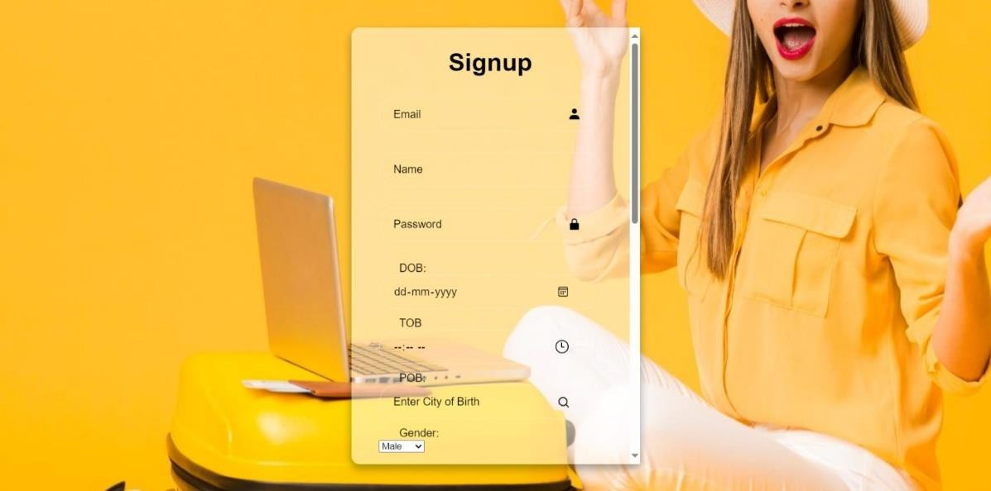

During the signup process, our web application seamlessly guides users through the account creation journey, starting with the collection of essential details to kickstart their experience. Users are prompted to provide basic information, including their name, email address, and password, to establish their account credentials securely. This initial step lays the foundation for their personalized journey on our platform, ensuring a seamless transition into the world of online dating.



In addition to capturing standard account details, we take a proactive approach to understand users' dating preferences and interests right from the start. During signup, users are prompted to specify their preferred genders and indicate their interests, enabling us to tailor their matchmaking experience accordingly. This thoughtful approach ensures that users are presented with potential matches that closely align with their dating criteria and preferences, right from the outset of their journey.

By collecting these preferences upfront, we empower users to define their dating preferences and expectations, setting the stage for a more personalized and fulfilling experience on our platform. This user-centric approach not only enhances user satisfaction but also increases the likelihood of meaningful connections being forged between users who

share common interests and values. Ultimately, our goal is to create a welcoming and inclusive environment where users feel empowered to express themselves authentically and explore genuine connections with like-minded individuals.

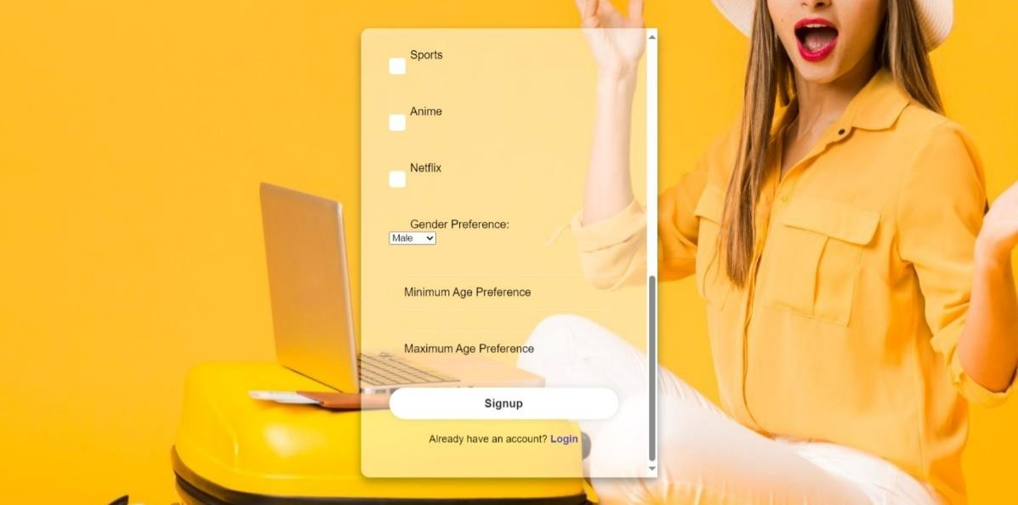

##### For Place of Birth Field:

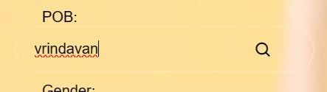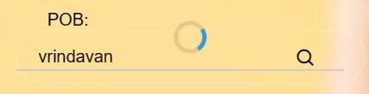

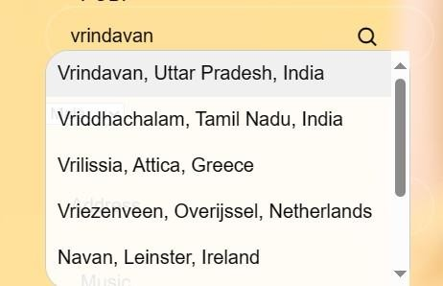



**Login Page:**



The login page of our web application offers users a streamlined and efficient way to access their accounts, requiring only their email address and password for authentication. This minimalist approach prioritizes simplicity and ease of use, allowing users to seamlessly sign in to their profiles without unnecessary complications or distractions. By focusing solely on the essentials—email and password—we ensure a frictionless login experience that caters to users' needs for convenience and efficiency.

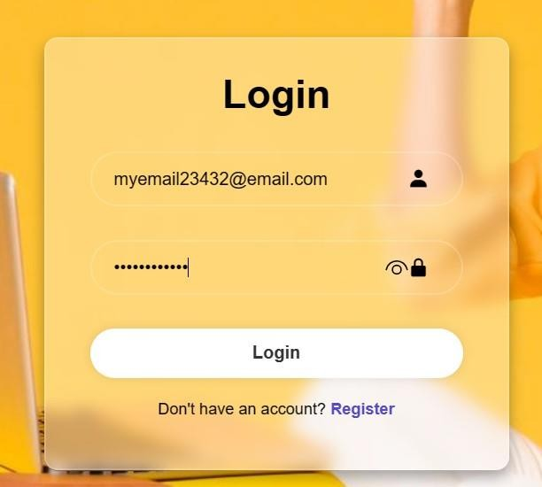

If we enter wrong email address.

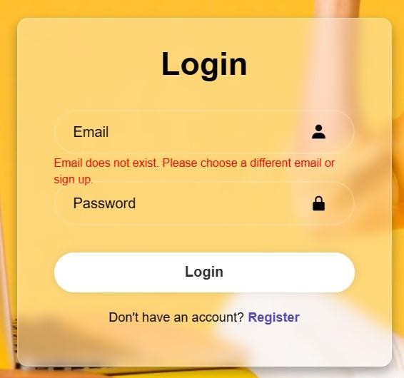

The minimalist design of the login page not only enhances usability but also encourages user engagement by eliminating unnecessary barriers to entry. With a clear and intuitive interface, users can quickly navigate to the login form, enter their credentials, and gain instant access to their accounts. This straightforward process minimizes user frustration and promotes a positive user experience, setting the stage for meaningful interactions and connections within the platform.

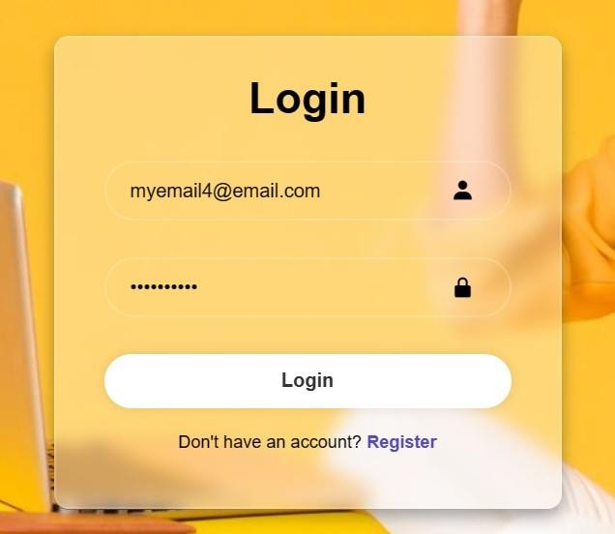

If we enter wrong password:

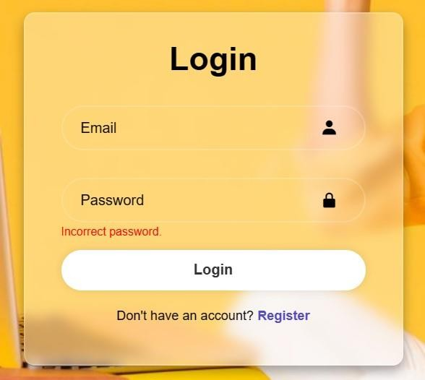

Moreover, by prioritizing simplicity in the login process, we uphold our commitment to user privacy and security. By requiring only essential information for login, we reduce the risk of data exposure and ensure that users can access their accounts securely. This emphasis on security reinforces user trust and confidence in our platform, fostering a safe and welcoming environment for all users.

In summary, the login page of our web application embodies our dedication to simplicity, efficiency, and user-centric design. By providing a seamless login experience with minimal friction, we empower users to quickly access their accounts and engage with the platform's features, ultimately facilitating meaningful connections and interactions within our community.

##### Dashboard:

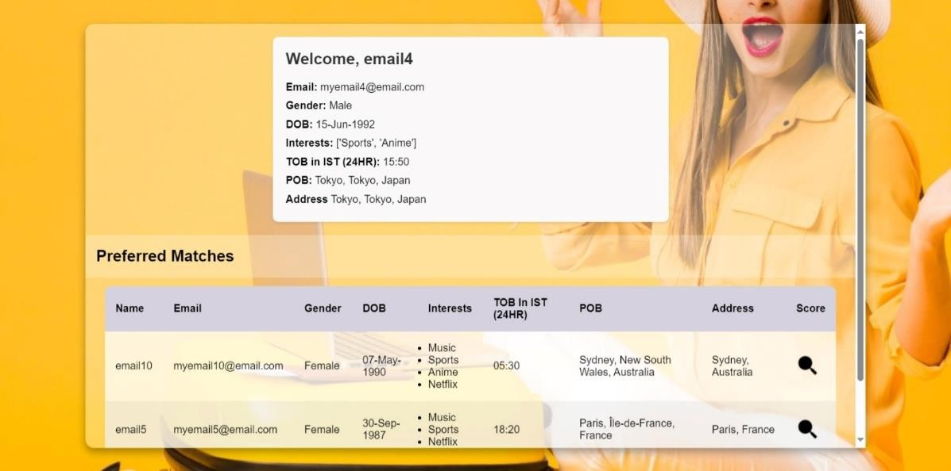

The dashboard serves as a centralized platform where users can effortlessly manage their online dating experience. Upon logging in, users are greeted with a comprehensive display of their personal details and preferred criteria alongside potential matches. This intuitive layout ensures that users have immediate access to essential information, streamlining their decision- making process and enhancing their overall experience.

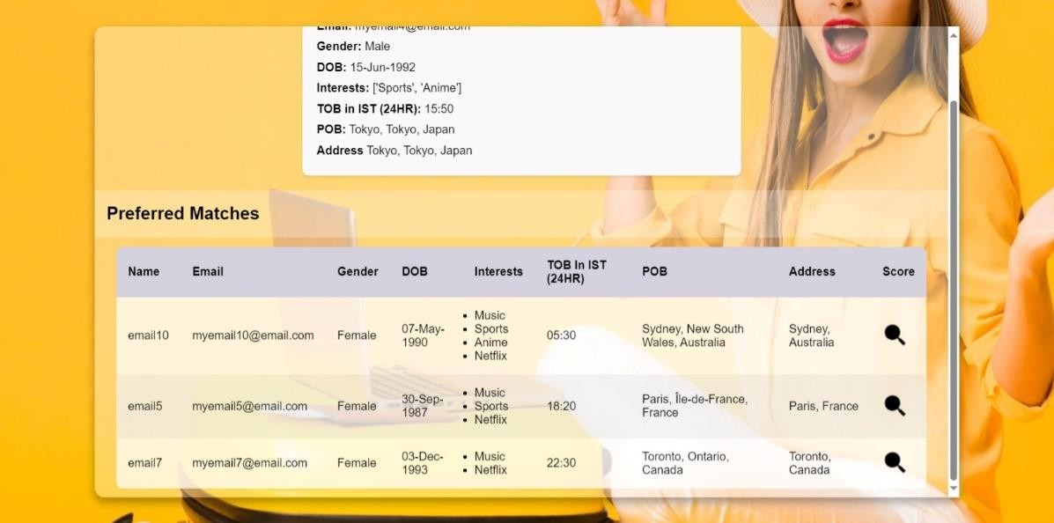

One of the key features of our dashboard is its integration of compatibility scoring, based on Bhartiya Jyotish Shastra principles. This scoring system provides users with valuable insights into the compatibility of their matches, helping them make more informed decisions about potential connections. The compatibility score, ranging from 0 to 36, signifies the alignment of key factors such as personality traits, values, and interests. A score of 18 or higher indicates a favorable match, while scores below 18 suggest potential compatibility issues.

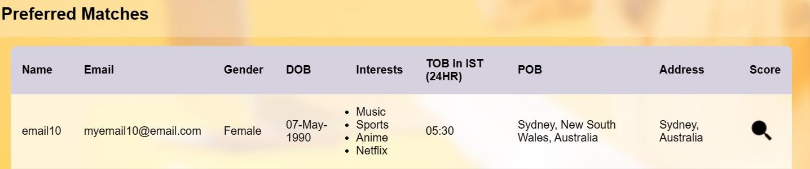

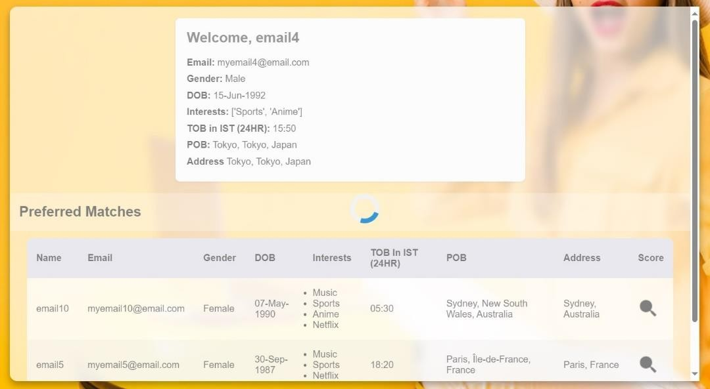

To further assist users in their decision-making process, the compatibility score is visually highlighted using color-coded indicators. Scores that meet or exceed the threshold of 18 are highlighted in green, signaling a positive match. Conversely, scores below 18 are highlighted in red, indicating potential compatibility concerns. This visual cue provides users with immediate feedback on the suitability of their matches, empowering them to prioritize connections that align with their preferences and values.

In addition to compatibility scoring, the dashboard offers users the ability to explore detailed profiles of their potential matches. These profiles include basic details such as age, location, and interests, allowing users to assess compatibility beyond the numerical score. By providing users with a holistic view of their matches, the dashboard enables them to make more nuanced judgments about compatibility and suitability.

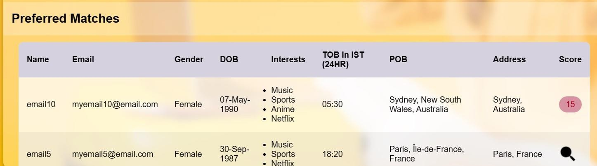

Overall, the dashboard serves as a user-centric tool designed to enhance the online dating experience. Its intuitive design and integration of compatibility scoring empower users to navigate the complexities of online dating with confidence and ease. By offering valuable insights and visual indicators, the dashboard facilitates meaningful connections and fosters a vibrant community of users within the platform. **T**hat users can effortlessly navigate through their matches and profiles. With a user-friendly interface and intuitive layout, the dashboard fosters engagement and encourages users to explore potential connections with ease. Additionally, by prominently displaying key information such as match recommendations and cosine similarity scores, the dashboard enables users to quickly assess their compatibility with potential matches and make informed decisions about their dating journey.

Overall, the dashboard serves as a powerful tool for users to manage their online dating experience effectively. By providing personalized match recommendations and valuable insights, it empowers users to navigate the complexities of online dating with confidence and ease. With its intuitive design and user-centric features, the dashboard enhances the overall user experience, facilitating meaningful connections and fostering a vibrant community of users within the platform.

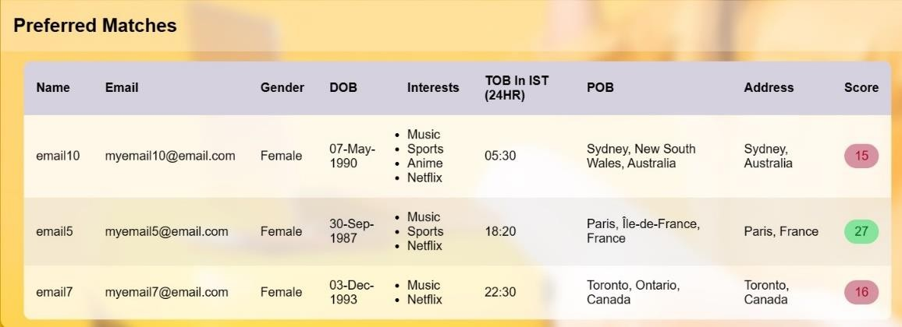

##### Some Dashboards for other Users:

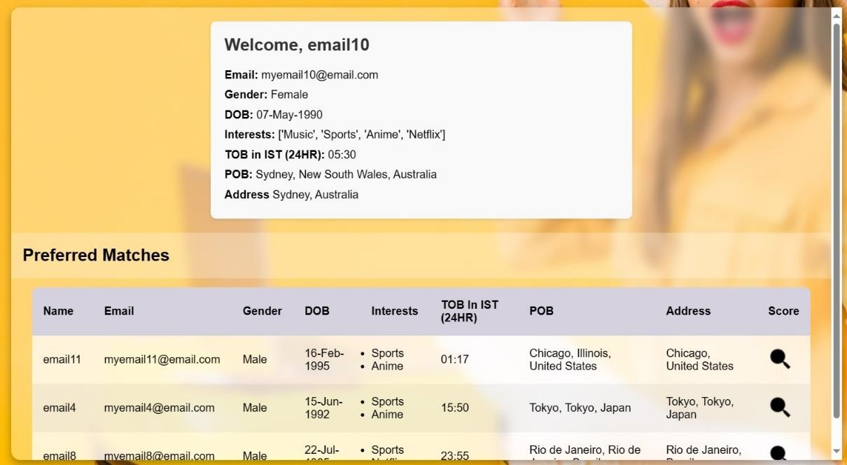

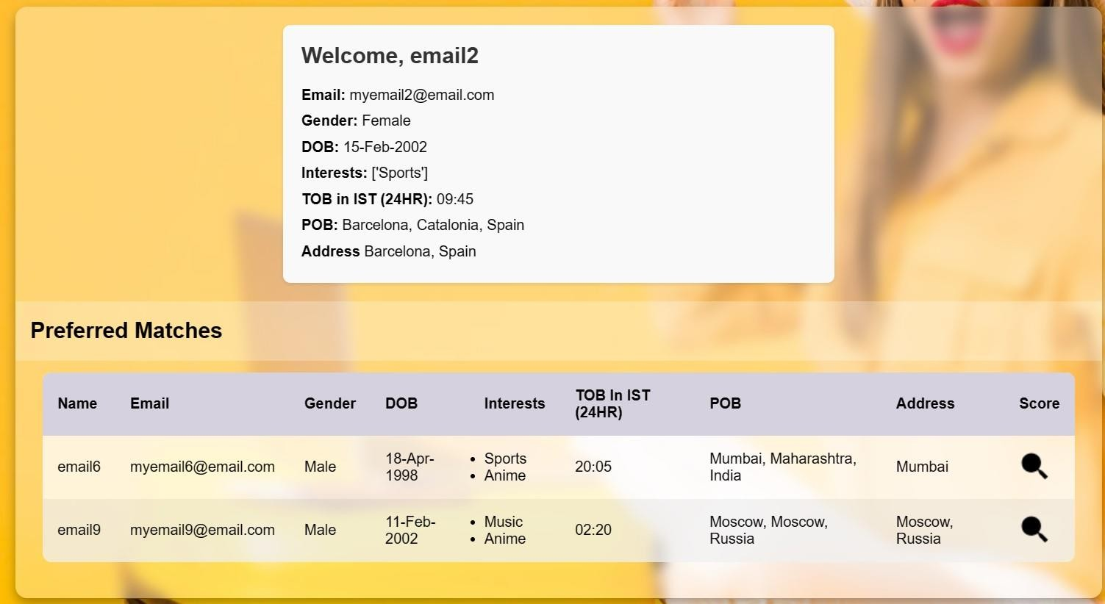

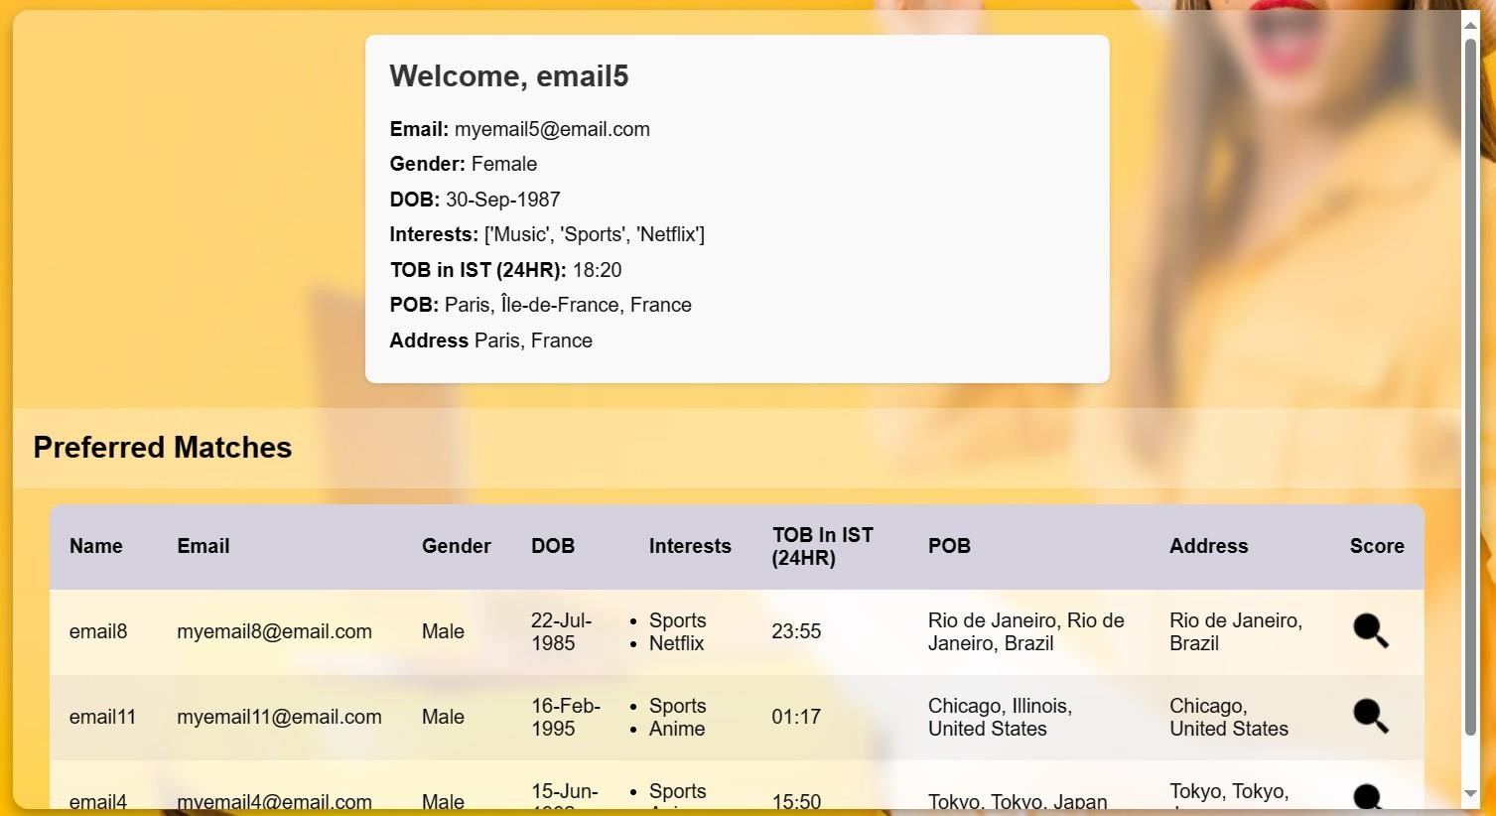

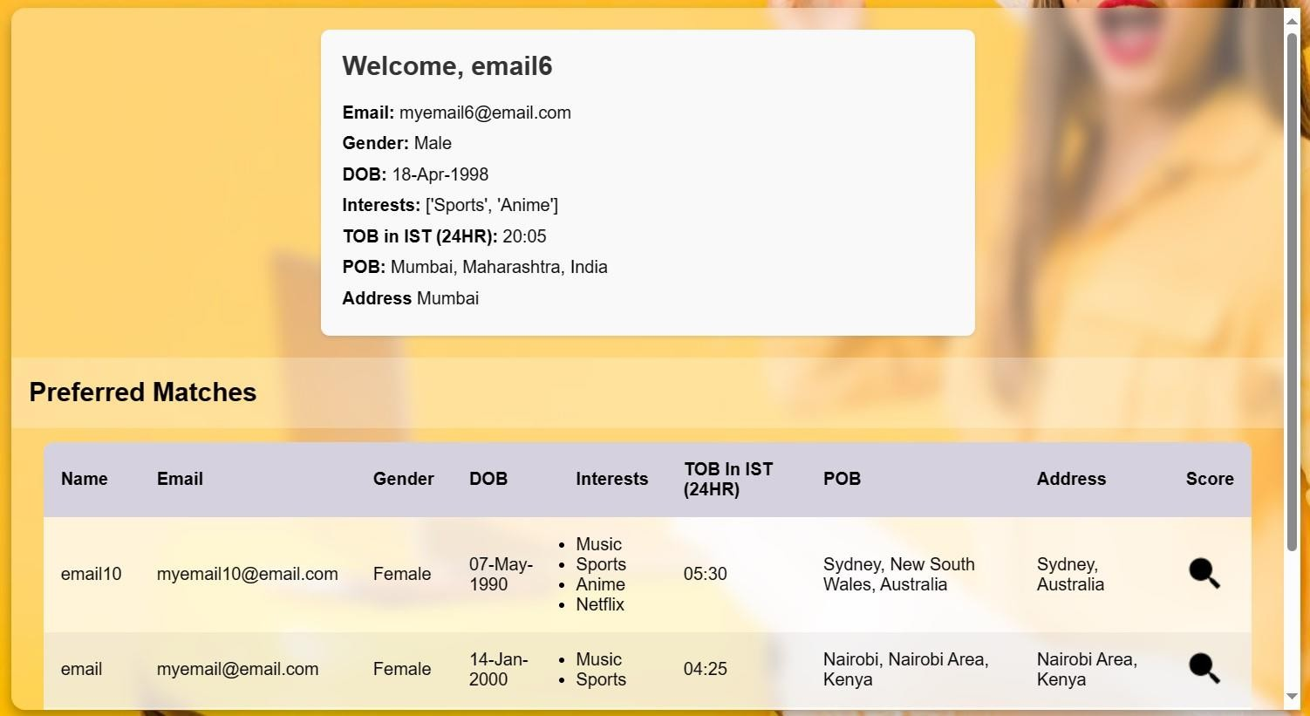

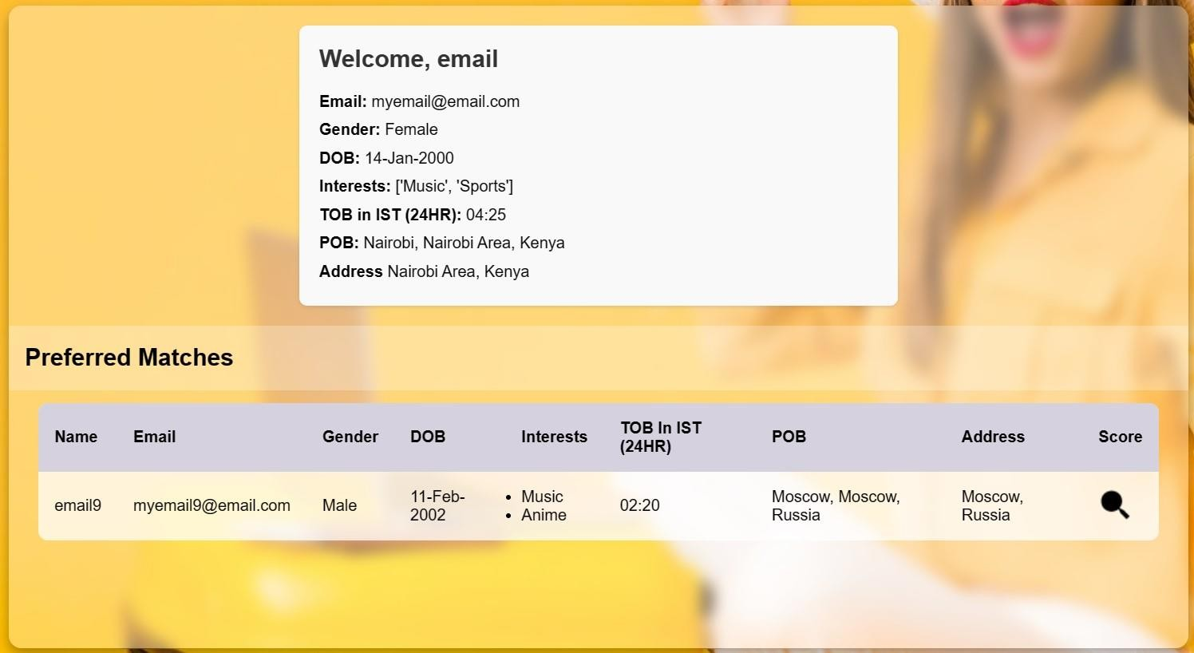

# Chapter 7

**Conclusion**

In the ever-evolving landscape of online dating, our project, "Predict Tinder Matches with Machine Learning," has embarked on a transformative journey driven by a steadfast commitment to enhancing user experiences and fostering meaningful connections. Recognizing the challenges inherent in traditional matchmaking methods, we set out to leverage technology to revolutionize the process and address the evolving needs of users worldwide.

At the heart of our project lies the innovative integration of Bhartiya Jyotish Shastra principles, enriching our matchmaking system with a depth of insight into compatibility beyond conventional algorithms. By incorporating this ancient wisdom into our modern approach, we offer users a holistic perspective on their potential matches, empowering them to make more informed decisions about their dating journey.

Our journey has been marked by significant milestones, each reflecting our dedication to delivering a superior online dating experience. The successful implementation of the cosine similarity algorithm stands out as a testament to our commitment to accuracy and relevance in match recommendations. This data- driven approach, complemented by the insights of Bhartiya Jyotish Shastra, ensures that users receive personalized and meaningful match suggestions tailored to their unique preferences and values.

Integral to our project's success is the meticulous design of the user interface, which prioritizes user experience (UX) principles to create a seamless and engaging journey for users. From the intuitive registration process to the detailed profile creation and exploration of potential matches, every aspect of the user experience has been carefully crafted to foster connections that resonate on a deeper level.

Privacy and data security have been fundamental considerations throughout our project's development. We have implemented robust measures to safeguard the sensitive information of our users, including stringent user consent mechanisms, data encryption protocols, and secure communication channels. By prioritizing privacy and security, we aim to build trust and confidence among our user base, fostering a safe and secure environment for online dating interactions.

As we reflect on our journey thus far, we are filled with optimism for the future of our project. While we have achieved significant milestones, we recognize that there is still much to explore and innovate upon. Future avenues include further refinement of our recommendation models, the enhancement of user interaction features, and the exploration of global expansion opportunities. With our unwavering commitment to enhancing the online dating experience, we are poised to continue making a meaningful impact in the lives of users worldwide, guided by the wisdom of Bhartiya Jyotish Shastra and the transformative power of technology.

# Chapter 8

**Summary**

In this conclusive summary, we encapsulate the essence of our ambitious endeavor, "Predict Tinder Matches with Machine Learning." Our mission was clear: to revolutionize online dating through the fusion of advanced machine learning techniques and user-centric design principles. With a focus on efficiency and personalization, we embarked on a journey fueled by innovation and dedication.

Our project's foundation rested on a robust framework of software requirements, encompassing essential tools like Python, machine learning libraries, and Firebase for seamless database management. This technological backbone enabled us to navigate through intricate stages of data processing and algorithmic implementation with precision and efficacy.

Organized into meticulously crafted modules, our project aimed to streamline every facet of the matchmaking journey. From the initial user registration to profile customization and interaction, our interface prioritized simplicity and intuitiveness, aiming to elevate user experiences and facilitate genuine connections.

The potential impact of our project on the online dating landscape is profound. By enhancing user experiences and fostering meaningful connections, we aspire to reshape the digital dating experience fundamentally. Looking forward, our project holds promise for continued innovation, with future avenues including advanced recommendation models and enhanced user interaction features.

As we reflect on our journey, we recognize the transformative power of technology in redefining human connections. Each milestone achieved serves as a testament to our commitment to pushing boundaries and enriching the lives of users worldwide. With optimism and anticipation, we embrace the future of online dating, confident in our ability to drive positive change through our innovative project.

# Refesrences

List of cited sources

* + 1. Bishop, C. M. (2006). Pattern Recognition and Machine Learning. Springer.
    2. Brown, D. (2017). Python Machine Learning. Packt Publishing.
    3. Géron, A. (2019). Hands-On Machine Learning with Scikit-Learn, Keras & TensorFlow: Concepts, Tools, and Techniques to Build Intelligent Systems. O'Reilly Media.
    4. Baldizzi, A., & Ingrosso, G. (2020). Recommender Systems: Building an Intelligent Recommendation Engine. Springer.
    5. Gruska, J. (2021). Python Machine Learning for Beginners. Packt Publishing.
    6. Hastie, T., Tibshirani, R., & Friedman, J. (2001). The Elements of Statistical Learning. Springer.
    7. Hastie, T., Tibshirani, R., & Friedman, J. (2009). The Elements of Statistical Learning: Data Mining, Inference, and Prediction. Springer Science & Business Media.
    8. Heaton, J. (2018). Artificial Intelligence for Humans. Heaton Research, Inc.
    9. Murphy, K. P. (2012). Machine Learning: A Probabilistic Perspective. MIT Press.
    10. Rendle, S. (2018). Machine Learning for Recommendation Systems: Algorithms and Applications. Morgan Kaufmann.
    11. Shalev-Shwartz, S., & Ben-David, S. (2014). Understanding Machine Learning: From Theory to Algorithms. Cambridge University Press.
    12. TensorFlow (2023). TensorFlow: Open source software for numerical

computation. tensorflow.org.

* + 1. Medium. Available at: https://medium.com/
    2. Towards Data Science. Available at: https://towardsdatascience.com/